Introduction
To enable users in your organization to log in with their Microsoft Azure AD identities, you must first set up a SpecterX App in your Azure AD. This will allow SpecterX to turn to Azure for authentication.

To renew credentials for an existing AzureAD <> SpecterX federation, go directly to the section for creating a secret, and send the newly generated credentials to support@specterx.com.

Please Note: For this walkthrough you will need Microsoft Azure Admin Portal access.

Step 1: Set up App Registration
- Go to the Customer’s Azure Admin Portal - https://portal.azure.com/#home
- Browse using the top search to Azure Active Directory
- Choose ‘App Registrations’
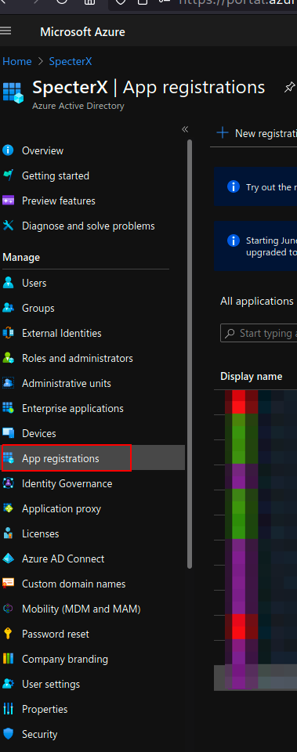
- Click “+ New registration” and fill the following details:
  - Name: SpecterX App Federated login
  - Supported account types: Accounts in this organizational directory only ({customer_name} only - Single tenant)
  - Don’t enter “Redirect URI” at this stage
  - It should look like this
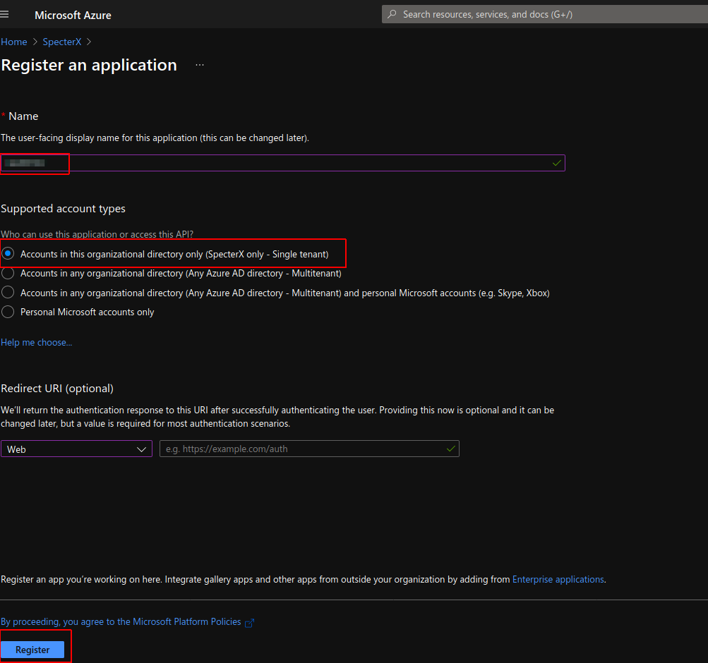
- Click “Register”
- Browse to the newly registered app
  - Copy and save Application (client) ID
- Click ‘Endpoints’.
  - Copy and save “OpenID Connect metadata document” URL
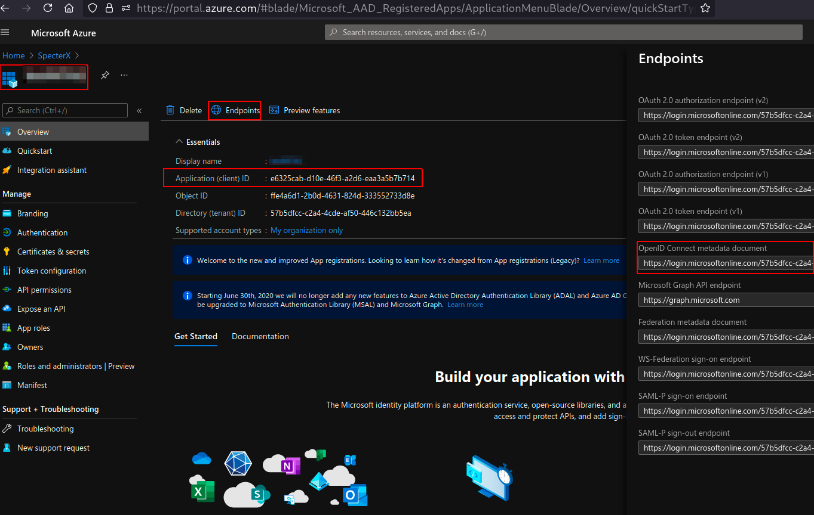

Creating a Secret
Creating a secret in Azure AD acts as a confidential key for your Azure AD’s secure communication with SpecterX.

- If you’re not already on the relevant app page in Azure, go to App Registrations in the Azure Admin Portal and find the app created for SpecterX authentication (should be under the name ‘SpecterX App Federated login’).
- Go to “Certificates and Secrets” on the left menu
- Under “Client Secrets” click “+ New client secret”
  - Set “SpecterX IdP” as the name
  - Set expiration to 24 months
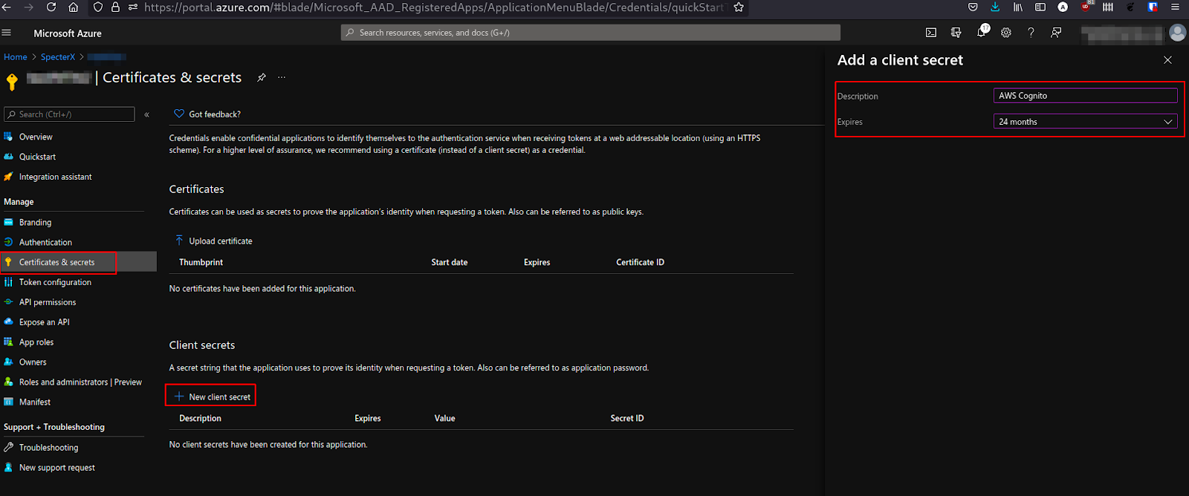
  - Click “Add” and you’ll see the secret “Value” in the “Client Secrets” table - copy it.
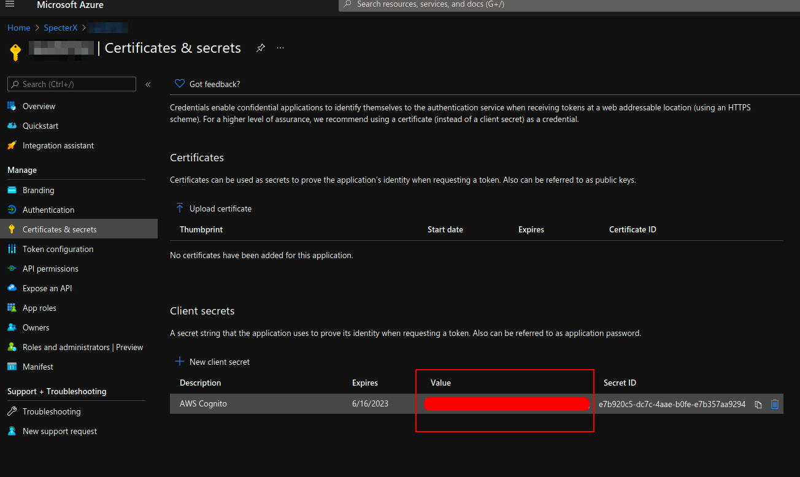

- Send the newly created secret value to a SpecterX support representative.

Step 2: Add Authentication Methods
- Return to the App Authentication menu to begin configuring the SpecterX app's authentication:

Setting up Web authentication
- Click on “+ Add platform” and select “Web” and click configure
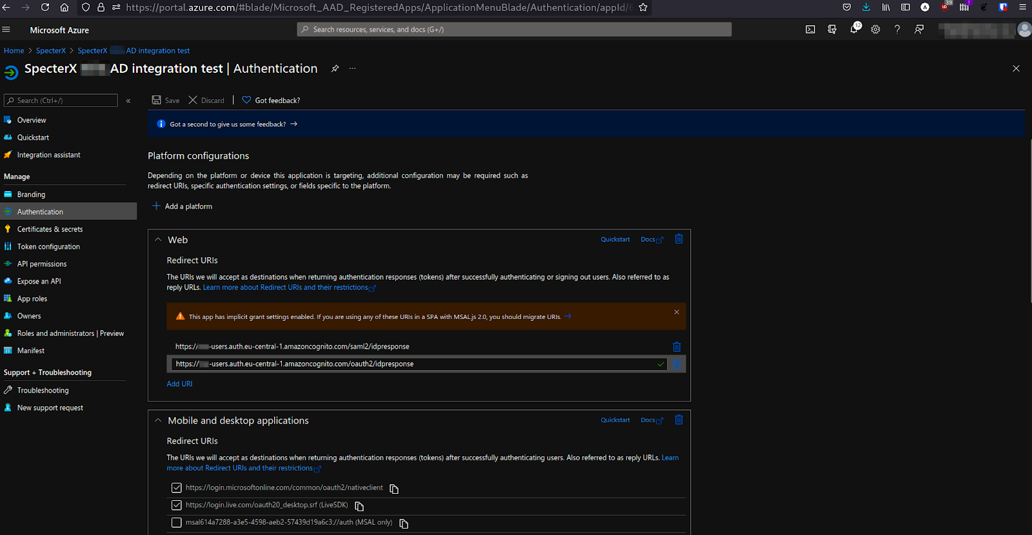Using the “Domain name” configured in AWS Cognito, make sure there are 2 redirect URIs:
- https://{customer}-users.auth.eu-central-1.amazoncognito.com/saml2/idpresponse
- https://{customer}-users.auth.eu-central-1.amazoncognito.com/oauth2/idpresponse

Setting up Authentication for Add-ins and other SpecterX components
- Click on “+ Add platform” again and select “Mobile and desktop applications”
- Select the following 2:
  - https://login.microsoftonline.com/common/oauth2/nativeclient
  - https://login.live.com/oauth20_desktop.srf
- On the same page find under “Implicit and hybrid flows” a checkbox named Access tokens (used for implicit flows) and check it.
- Click Save.

Update Identifier URIs
- Next, we’ll update the Identifier URIs for the Azure AD app registration you created.
The simplest way to do this is by editing the Manifest (Method #1). If for some reason you don’t have access to edit this manifest, continue to Method #2.
You only need to do one of them.

Method #1 - Using the Manifest editor in Azure AD
- Click on the left-side menu on ‘Manifest’ to arrive at the Manifest editor. It will look something like this:
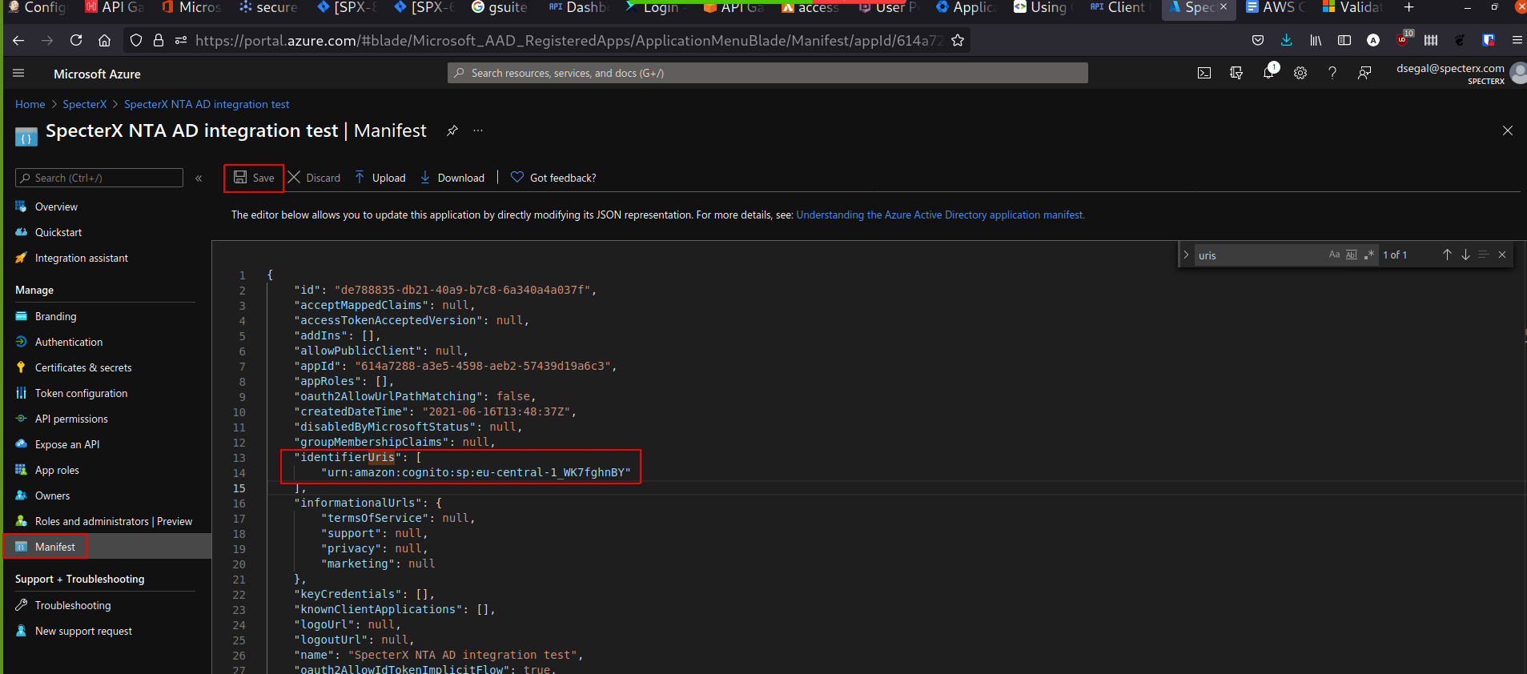
- Here you will need to update the identifiersUris value to match your SpecterX tenant ("urn:amazon:cognito:sp:<tenant_uri_value>"). The SpecterX team will provide you with your dedicated tenant value.

Method #2 - Using PowerShell (only in case Method #1 is not applicable)
In case your Azure Admin doesn’t allow you access to the Manifest file, we offer this alternative configuration method.
For this method you’ll need to have the AzureAD Powershell module installed.
- If you already have the AzureAD Powershell module installed, you can skip to step 2.
If you haven't yet, complete the following steps::
For Windows 10 users:
  - Open a PowerShell session as Administrator
  - Install it by running the following lines:
Install-Module -Name AzureAD
For other users:
  - Download the AzureAD Powershell from powershellgallery.com.
- Run the following lines:
Connect-AzureAD
- Enter credentials for the customer’s admin user in Azure AD for the following command.
- Run the following lines:
Get-AzureADApplication

You should see the name of “App registration” that you have created in the steps above.

- Get the ObjectId for the application you’re trying to set the App ID for
- Run the following lines:
Set-AzureADApplication -ObjectId OBJECTGUIDHERE -IdentifierUris "urn:amazon:cognito:sp:<tenant_uri_value>"
- Note: If you get Authorization failure - you may temporarily add “Global Adminisitrator” permissions to the user performing the action, execute the command, and remove the permissions.

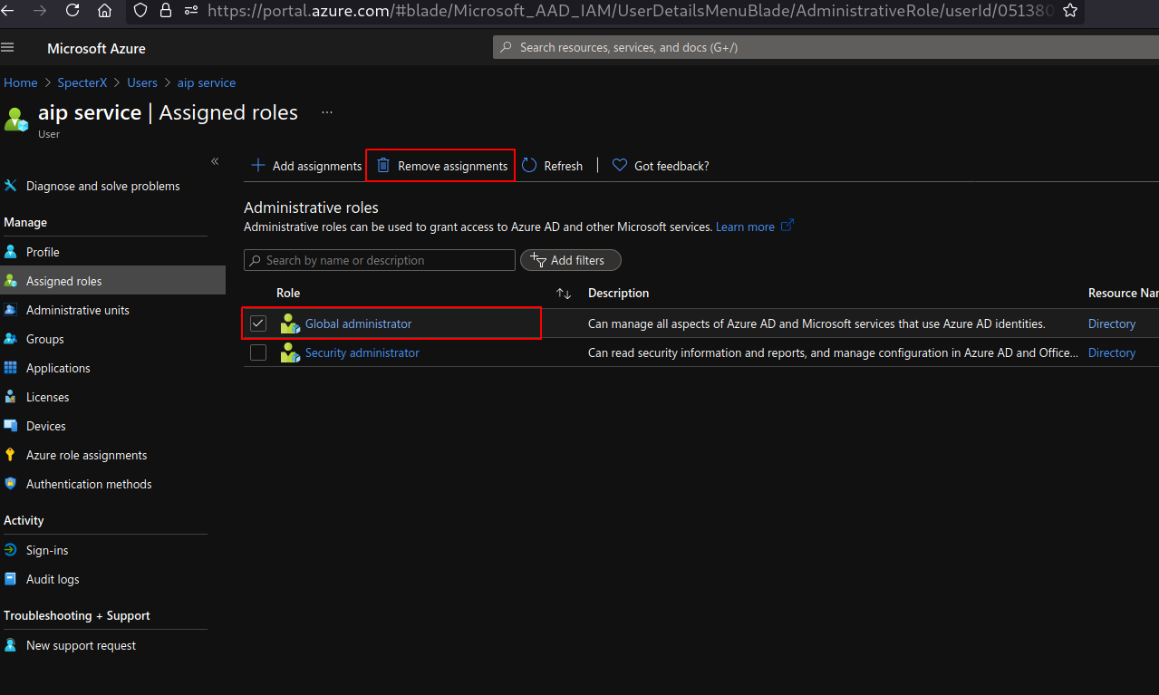

- Confirm that the value was correctly applied to the IdentifierUris attribute, by running the following command:
Get-AzureADApplication -ObjectId OBJECTGUIDHERE |fl

